NEW FOREST
TODDLE
Thursday 26 October
10am – 12pm
Fawcetts Field sports ground
New Milton BH25 6QF
- FREE family nature activity walk for toddlers and young children
- Organised by the New Forest National Park Rangers
- Half-mile walk suitable for buggies, pushchairs and wheelchairs
- Well behaved dogs on short leads welcome
- Book via Walking and Cycling Festival 2023: New Forest toddle Tickets, Thu 26 Oct 2023 at 10:00 | Eventbrite
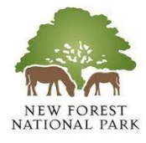
Part of the 2023 New Forest Walking Festival

